Sequence Diagram demonstrating operation “Add a new room”

• This diagram describes the system scenario of “UC210: Add a new Room”

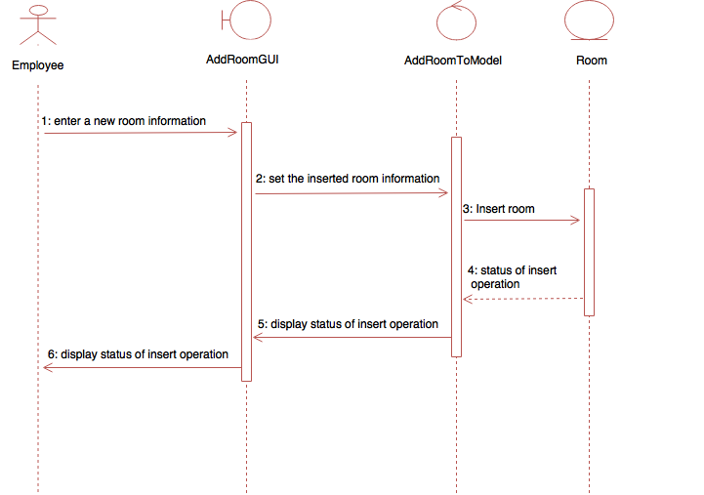

Sequence Diagram demonstrating operation “Add a new building”

• This diagram describes the system scenario of “UC220: Add a new Building”

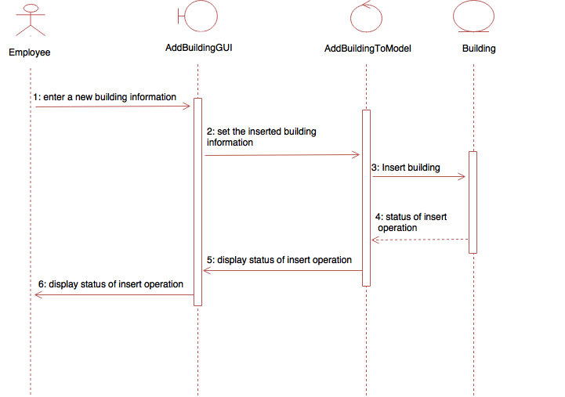

Sequence Diagram demonstrating operation “Delete a room”

• This diagram describes the system scenario of “UC230: Delete a Room”

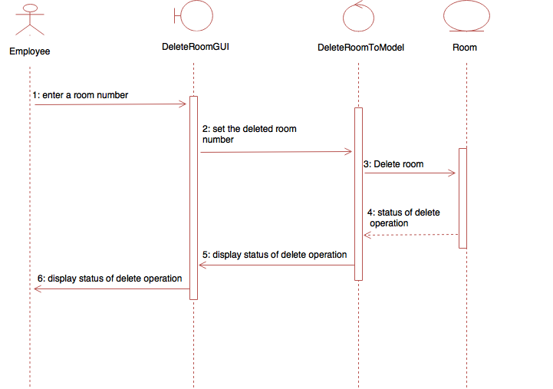

Sequence Diagram demonstrating operation “Delete a building”

• This diagram describes the system scenario of “UC240: Delete a Building”

